Council Minutes – March 12th, 2023
Prepared by Margaret Ann Gillis, Deputy Chair

Agenda of March 12th Council Meeting
- Call to Order
- Roll Call
- Land Acknowledgement
- Opening Remarks of the Chair
- Approval of the Agenda
- Approval of the February 12th Council Meeting Minutes
- Constituency Reports
- Executive Reports
- Students’ Union General Manager Report
- Special Reports to Council
  - 1hr presentation from VPFO Sam Delaney and Julianne Mattie, “Draft 2023-2024 STFX SU Budget.”
  - 5min presentation from VPFO Sam Delaney and Julieanne Mattie, “SU Endowment Fund.”
  - 30min presentation from Gina Sampson, Office of the Academic Vice President (Amanda Cockshutt), “Academic Plan.”
- New Business
  - A motion to withdraw 50% of the investment gain on the SU endowment fund investment for the next 5 years, to contribute to repaying the interest costs for the Bloomfield Renovation Loan.
  - A motion to strike an ad hoc hiring panel that consists of 4 councillors to prepare and review application forms, hold interviews and make candidate recommendations at a future council meeting.
  - Ratification of Matthew Doyle as VP External Affairs from May 1st, 2023, to April 30th, 2024.
  - Ratification of Henderson Cartwright as VP Campus Affairs from May 1st, 2023, to April 30th, 2024.
  - Ratification of Julianna Drake as VP Finance & Operations from May 1st, 2023, to April 30th, 2024.
  - A motion to approve the election act with the incorporation of subsection 67.
- Closing Remarks of the Chair
- Adjournment

Students’ Union Representative Council Meeting
March 12th, 2022 | 12:05pm – 2:33pm ADT
SU Council Chambers, Bloomfield Hall

Call to Order
Molly: “I call this meeting to order at 12:05pm.”

Roll Call
VP Activities & Events – Kali Beaton
Indigenous Student Representative – Harmony Bright-Doucette
Chair of Council – Molly Burke
International Student Representative – Francisco Chang
Business Representative – Dylan Clark
VP Finance & Operations – Sam Delaney
VP Residence Affairs – Sophia Fabiano
VP External Affairs – Ben Fairhurst
Deputy Chair of Council – Margaret Ann Gillis
Arts Student Representative – Jack Harding
First Year Representative – Christian Lejeune
General Manager – Sean Ryan
Board of Governors Representative – Violet Silva
VP Academics – Naomi Stobart
Equity Representative – Caspian Tohidian

Absent with Regret
Indigenous Student Representative – Sierra Julian
Board of Governor Representative – Josh Kroker
President & CEO – Brendan Roberts
Graduate Student Representative – Julia Schmitt
Education Representative – Katherine Waterbury

Land Acknowledgement

Molly: “I would like to begin by acknowledging that we are in Mi’kma’ki, the ancestral and unceded territory of the Mi’kmaq People. This territory is covered by the Treaties of Peace and Friendship, which Mi’kmaq and Wolastoqiyik peoples first signed with the British Crown in 1725. The treaties did not deal with the surrender of lands and resources but in fact, recognized Mi’kmaq and Wolastoqiyik titles and established the rules for what was to be an ongoing relationship between nations. As a Wolastoqiyik student on Mi’kma’ki land, I will continuously educate myself on what it means to be on this land that I am on and be an ally for the Mi’kmaq people who have never surrendered it.”

Opening Remarks of the Chair
Molly: “Hi guys! This is gonna be a kind of long council today. Reminder not to leave during presentations or voting time – I will give you a break during presentations.”

Approval of the Agenda
Jack: “I move to approve the agenda.”
Francisco: “I second.”
No Discussion.
Naomi: “I will call to question.”
Francisco: “I second that.”
Motion passes unanimously.

Approval of the Minutes of February 12th Council Meeting
Naomi: “I motion to approve the February 12th Council minutes.”
Jack: “I will second.”
No discussion
Caspian: “I call to question.”
Jack: “I second.”
Motion passes unanimously.

Constituency Reports
Please see the March 12th Council Package for Constituency Reports. Below is any discussion had concerning reports, or reports submitted after the deadline. Equity Representative Caspian Tohidian, First Year Representative Christian Lejeune, and Business Representative Dylan Clark did not submit reports for this reporting period.

Board of Governors Representative – Joshua Kroker
Position Business:
- Met with the Board of Governors Advancement and External Relations Committee. This was the committee’s first meeting with the new Vice President Advancement, Mr. David Graham. The committee is focused on achieving StFX’s strategic plans.
- Attended the Board of Governors Governance and Nominating Committee. It was a productive meeting discussing future appointments and the importance of diversity for the Board.
- Discussed and updated the Students’ Union Council governing documents with the Governance Review Committee, most recently the Elections Act.
- Missed the February Board of Governors meetings to celebrate my uncle Del Volk’s life in Victoria, BC
Other Business:
- Participated in Chaplain Fr. Donald MacGillivray’s “Man’s Journey” at Camp Geddie.
- Received a Council Initiative of $300 for the Ceilidh, organized by Catholics @ X.

Executive Reports
Please see the March 12th Council Package for Executive Reports. Below is any discussion had concerning reports. VP External Ben Fairhurst did not submit a report for this reporting period.

Student Union General Manager’s Report
General Manager – Sean Ryan
Sean: “There will be invitations going out for the awards banquet soon – get back to me ASAP with any dietary restrictions. There’s also a nomination form up on TheU’s website, and we’ve collaborated with the DEC so we can have one big celebration with everyone. Lots of awards so go nominate some folks who need to be recognized for the work they’ve done on campus.”
No discussion.

Special Reports to Council
- 1hr presentation from VPFO Sam Delaney and Julianne Mattie, “Draft 2023-2024 STFX SU Budget.”
- 5min presentation from VPFO Sam Delaney and Julieanne Mattie, “SU Endowment Fund.”
- Academic Plan from Gina Sampson, Office of the Academic Vice President (Amanda Cockshutt).

New Business
A motion to withdraw 50% of the investment gain on the SU endowment fund investment for the next 5 years, to contribute to repaying the interest costs for the Bloomfield Renovation Loan.
Caspian: “I will motion.”
Naomi: “I second.”
No discussion.
Violet: “I call to question.”
Francisco: “I second that.”
Motion passes unanimously.

A motion to strike an ad hoc hiring panel that consists of 4 councillors to prepare and review application forms, hold interviews and make candidate recommendations at a future council meeting Board meeting to hire the chair of the board.
Discussion:
Molly: “I would like to make a friendly amendment to make the motion say a future board meeting, and at the discretion of the Chair of the Board.”
Naomi: “I motion to strike an ad hoc hiring panel that consists of 4 councillors to prepare and review application forms, hold interviews and make candidate recommendations at a future Board meeting to hire the Chair of the Board.”
Francisco: “I second.”
Naomi: “I yield time to Sean.”
Sean: “What you’re agreeing to is that we strike an ad hoc committee, and 4 people step up and we select a chair of the other committee.”
Christian: “I call to question.”
Caspian: “I second that.”
Motion passes unanimously.
Ratification of Matthew Doyle as VP External Affairs from May 1st, 2023, to April 30th, 2024.
Discussion:
Jack: “I will motion to ratify Matthew Doyle as VP External Affairs from May 1st, 2023, to April 30th, 2024.”
Francisco: “I second.”
Jack: “I yield time to Sophia.”
Sophia: “Jack and I have been going through the hiring process for our three exec team members for next year. With the change in terms of reference, me, Jack and Sean Ryan sat on the panel. We send out applications and got the word out to as many groups on campus as possible. We had our panels the week after reading week and had to reopen applications for one of the positions for more applicants. This weekend Jack and I wrote out a hiring mission statement to help us figure out what we want on our exec team next year, and something to go back to on more difficult points to drive home our decision. We had 6 applicants and we interviewed three people, and we selected Matthew Doyle because he interviewed very well and meets our mission statement.”
Jack: “I yield time to Sean.”
Sean: “At the beginning of each interview session, I asked panelists if there was any bias, and I didn’t feel at any time there was a conflict of interest that negated the panel.
No discussion.
Francisco: “I call to question.”
Caspian: “I second that.”
Motion passes unanimously.

Ratification of Henderson Cartwright as VP Campus Affairs from May 1st, 2023, to April 30th, 2024.
Discussion:
Jack: “I think we had 9 applicants and they were very strong applicants, but Henderson gave a standout interview and hit all the points we’re looking for in terms of the direction we want to take theU. Lots of creativity and new perspective we’re looking for – we’re very excited to have him on the team!
Caspian: “I will motion.”
Francisco: “I second.”
No discussion.
Naomi: “I call to question.”
Francisco: “I second that.”
Motion passes unanimously.
Ratification of Julianna Drake as VP Finance & Operations from May 1st, 2023, to April 30th, 2024.
Discussion:
Jack: “I yield time to Sophia.”
Sophia: “We had 6 candidates for the VPFO position and interviewed 3. Julianna has previous finance experience and we thought she’d be a great part of our team. We’re so excited!”
Jack: “I will motion.”
Christian: “I second.”
No discussion.
Jack: “I call to question.”
Caspian: “I second that.”
Motion passes unanimously.

A motion to approve the election act with the incorporation of subsection 67.
Discussion:
Dylan: “I will motion.”
Francisco: “I second.”
No discussion.
Caspian: “I call to question.”
Naomi: “I second that.”
Motion passes unanimously.

Closing Remarks
Molly: “That’s everything! I’ll see y’all soon!”

Adjournment
Jack: “I’ll move to adjourn.”
Caspian: “I’ll second.”
No discussion.
Motion passes unanimously.
Meeting adjourned at 2:33pm ADT

Appendix Item I: Endowment Fund Terms of Reference
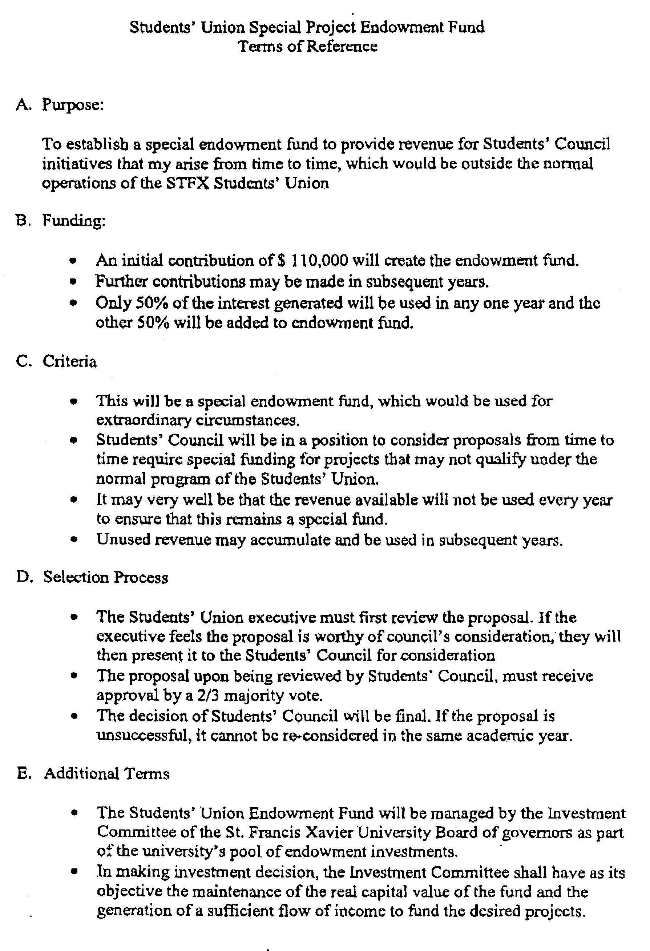
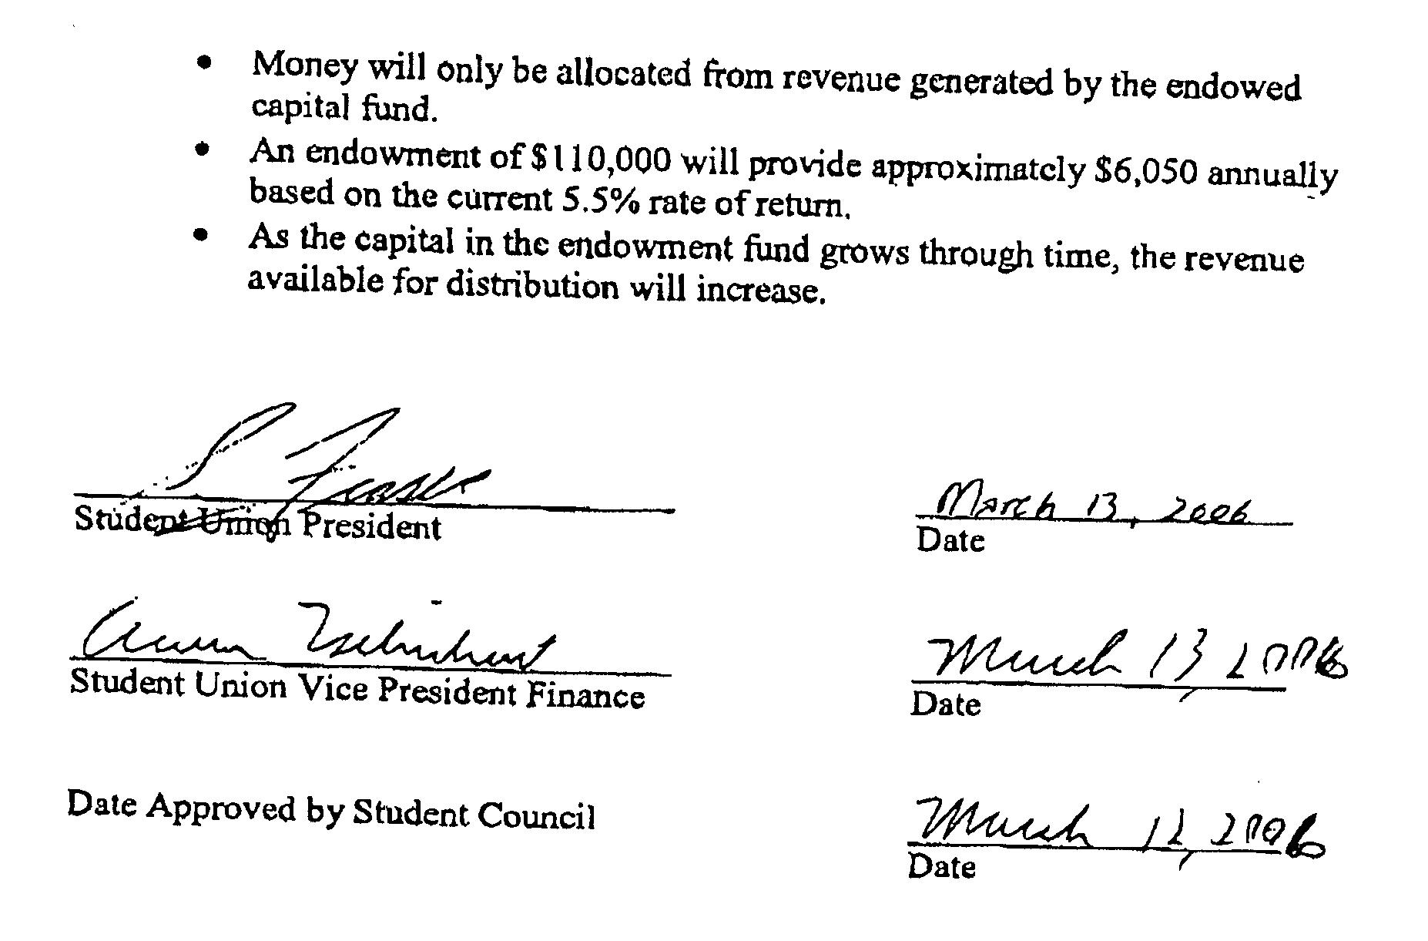

Appendix Item II: Elections Act

Elections Act
- Any situations not outlined in this policy will be addressed at the discretion of the Returning Officers and the Elections Committee.
Definitions
- The following definitions shall be applied throughout this policy.
  - Active campaigning:
    - The distribution of campaign materials.
    - Speaking to Union members for the purpose of representing a platform or candidate.
    - Hosting events, speaking sessions or gatherings for the purpose of representing a platform or candidate.
  - Non-active campaigning:
    - Attending campaign meetings.
    - Helping develop candidate platforms.
    - The production of media advertisements and publicity materials (posters, t-shirts, website, social media posts)
  - Campaign material – Publicly shared material produced for the purpose of promoting a candidate or platform.
  - Harassment – Persistent or aggressive unwanted physical, verbal, or cyber behaviour that is intimidating or unwelcome.
  - Acting in an official capacity – An employee or volunteer of the Union who is performing the duties required by their office and their respective position’s Terms of Reference.
  - Slander – False or malicious attacks on another candidate's character and/or reputation.
  - Coercive Campaigning – Compelling a voter to make an involuntary or undesirable decision.
Election Scheduling
- The Chief Returning Officer may choose an election schedule that is not consistent with this policy by writing a proposal to the Board. This proposal will contain the reason for alternative dates, and an election schedule containing nominations dates, the all candidates meeting date, campaigning dates, debate nights, and polling dates. The Board may approve the proposed schedule by 2/3 majority at the next meeting of the board.
- Where fewer nominations than available positions/seats have been received, the Chief Returning Officer may extend the nomination period for up to an additional seven (7) days.
General Election
- Nominations for the Students’ Union General Election will open on the Feast Day of St. Francis Xavier, December 3rd, of each year and close before the end of the first week of January.
- The all-candidates meeting will take place after nominations have been closed for at least one (1) day and before campaigning may begin.
- Campaigning for the Students’ Union General Election will last for a period of ten (10) to twenty-one (21) days.
- Candidates may begin campaigning at the start of the general campaign period and must cease at the close of the polls.
  - Campaigning that takes place during the voting period must be with materials that were previously approved by the Returning Officers. No new materials may be introduced.
- The polling for the Students’ Union General Election will take place during the last week of January.
- The polling for the Students’ Union General Election will last for two (2) days.
- The Students’ Union General Election will include the elections of the Students’ Union President, Students’ Union Vice-President Academic Affairs, Board of Governors Student Representative.
- For the Students’ Union General Election, the Returning Officers shall hold at least one (1) all-candidates' debate.
Representatives Election
- Nominations for the Representatives Election will open ten (10) to twenty-one (21) days after the General Election and be open for a period of seven (7) to fourteen (14) days.
- The all-candidates meeting shall take place after nominations have been closed for at least one (1) day and before campaigning may begin.
- Campaigning for the Representatives Election will last for a period of (7) to fourteen (14) days.
- Candidates may begin campaigning at the start of the general campaign period and must cease at the close of the polls.
  - Campaigning that takes place during the voting period must be with materials that were previously approved by the Returning Officers. No new materials may be introduced.
- The polling for the Representatives Election will last for one-two (1-2) days.
- The Students’ Union Representatives Election will include the elections of the Student Senators and all Board of Directors positions.
By-elections and Other Elections
- All other elections, including by-elections will be scheduled by the Chief Returning Officer.
- Nominations for these elections will be open for a period of seven (7) to ten (10) days.
- The all-candidates meeting will take place between the closing of nominations and the beginning of campaigning.
- Campaigning for these elections will begin a minimum of seven (7) days before the polling start date.
- Polling for these elections will last for a period of one (1) to two (2) days.
Nominations
- The Chief Returning Officer shall issue a proclamation not later than the day nominations are opened indicating:
  - The position(s) to be run for;
  - When nominations open;
  - When nominations close (including the exact hour);
  - Where to receive a nominations form;
  - Any other information deemed appropriate;
  - The Returning Officers’ email, where questions can be directed.
- To be valid, nomination forms must contain the requisite number of eligible signatures. Students may not sign any more than one nomination form for any given position.
- The required number of signatures are:
  - President requires twenty-five (25) nomination signatures;
  - Vice-President Academic Affairs requires twenty-five (25) nomination signatures;
  - All other Elected Officials requires ten (10) nomination signatures.
- Valid nomination forms must be submitted to the Chief Returning Officer’s Office by the exact hour nominations close.
- The Chief Returning Officer reserves the right to re-issue invalidated nomination forms for a time period of two (2) to twenty-four (24) hours to allow the candidate to correct it. Candidates failing to correct invalidated nomination forms within the allotted time period will void their applications for nomination. Those individuals will have to restart the nomination process with a new form, and re-submit their deposit.
- The Chief Returning Officer will inform all candidates who have been successfully nominated that their nomination has been accepted and inform them of the date and time of all candidates meeting which must take place prior to said candidate undertaking campaign activities. The purpose of this meeting is for the Returning Officers to go over campaign rules/regulations and to give the candidates a copy of the Elections Act.
- Nominations will not be accepted without submission of the required deposit.
- Candidates may withdraw their nominations any time before the poll opens.
- Candidates withdrawing their nomination may do so by delivering a signed written notice to the Chief Returning Officer.
Eligibility Regulations
- Only Ordinary Members of the Union are eligible to run for Union positions.
- Candidates seeking nomination may not hold more than one elected position in the Union at any one time.
- Any Students’ Union Elected Official, Returning Officer, Deputy Chair of the Board intending to run for any position within the Union must give the Chair’s Office written notice of a leave of absence. This leave of absence will encompass the period of the campaign and voting period. During this time, the absent Elected Official, or member of the Chair’s Office may not conduct business within their office.
  - Should the Chair intend on running for an elected office, they are required to submit a similar request for a leave of absence to the Deputy Chair of the Board.
- Any hired or volunteer member (excluding those listed above) of the Students’ Union intending to run for any elected position within the Union will be required to serve in their official capacity throughout the campaign and voting period.
- These candidates outlined in section 34 seeking office may resume their positions after the validation of the elections (48 hours). If a re-election has been granted after an appeal process the said candidates are required to re-submit a notice of their leave of absence.
- All candidates must meet the eligibility requirements as outlined in the Union’s Eligibility Policy.
Campaign Regulations
- All elected positions must run separate election campaigns.
- Candidates may begin campaigning at the start of the general campaign period and must cease at the close of the polls.
  - Campaigning that takes place during the voting period must be with materials that were previously approved by the Returning Officers. No new materials may be introduced.
- Candidates may not harass students while engaging in the voting and campaign period. Harassment is defined in section 2.4 and also includes:
  - Promoting the election or a candidate’s platform to someone who has not asked for more information about it.
  - Candidates and their teams may not coerce or pressure voters into making a decision.
- All advertisements used during the campaign shall not be discriminatory on the basis of gender, sexual orientation, age, race, class, religion, creed, ancestry and country of origin, ethnicity, disability or other grounds.
- All advertisements shall not be in violation of; Copy Rights, The Canadian Charter of Rights and Freedoms, or any applicable municipal, provincial and federal laws.
- All signage must follow the Bloomfield S.U.B. poster policy and the poster policy of any other locations on campus. It is the candidate’s responsibility to find out the details of these poster policies and candidates will be held responsible if the Chief Returning Officer is notified that they are in violation of any policies.
- All candidates are responsible for the actions of their campaign workers, including scrutineers and campaign managers. Campaign workers who violate this act will cause the candidate to be disciplined as outlined in the Violations and Discipline section of this policy.
- Candidates may appoint campaign volunteers for the election process.
  - All campaign volunteers must be disclosed to the Chair’s Office prior to the start of the campaign period.
  - Candidates are responsible for all actions of the campaign volunteers as they pertain to the election, including but not limited to:
    - Physical promotions both during and after the campaign period
    - Electronic promotions both during and after the campaign period (i.e. any social media posts)
- All Students’ Union Employees and elected officials shall remain officially neutral while acting in their capacity as Union employees.
  - “Officially neutral” shall be defined as:
    - Engaging in no campaigning whatsoever;
    - Being non-exclusive in providing information and/or insight to candidates.
- The Chair of Council, Deputy Chair, Returning Officers, debate moderators, and Web Administrators shall remain impartial throughout the campaign.
- The Students’ Union President and Vice-President Academic Affairs shall remain impartial throughout the campaign, unless they are running upon the approval of the Chair’s Office.
  - If they are running, the candidate shall remain neutral for all other open candidacies in said election.
- All elected Student Representatives and hired executives shall be restricted from active campaigning, as defined in this policy, always. They may, however, be involved with non-active campaigning. This includes, but is not limited to:
  - Attending campaign meetings;
  - Helping to develop candidate platforms;
  - The production of media advertisements, including posters, t-shirts, static (website) and social networking electronic media.
- Union employees aside from Elected Officials, members of the Chairs Office, and non-student staff may actively campaign when they are not acting in the official capacity of their role.
- All physical publicity material (i.e. posters) must be removed within 48 hours of the closing of the polls. Failure to comply shall result in the refusal to partially or fully reimburse the candidate’s deposit, subject to the discretion of the Chair.
- Any nominees or incumbent employees of the Students’ Union including Executives and sub-executives are forbidden from using any resources not accessible to non-incumbent employees or volunteers, including but not limited to:
  - Printing, photocopying, email list-serves, advertising, monetary funds, office space, areas in Bloomfield, (unless monetary compensation is paid to Bloomfield centre); or any other resources that they may be privy to as a result of their position.
  - Nominees found using these resources will be subject to sanctions.
  - Students’ Union Employees and volunteers found aiding a nominee using resources not accessible to non-incumbent employees will be dealt with by the Students’ Union Elections Committee who may recommend action be taken by the responsible authority.
Deposit
- Deposits must be submitted to the Chief Returning Officer along with the nomination form.
- Deposits will be as follows:
  - President candidates will deposit $50.00;
  - Vice President candidates will deposit $50.00;
  - All other candidates will deposit $25.00.
- The Chief Returning Officers will keep the deposits until the results are finalized, 48 hours after the polls close.
- Deposits are reserved for potential incurred fines during the election process.
- If a candidate’s deposit is depleted due to incurred fines during the campaign, the candidate will be required to submit a second deposit in the same amount as the initial deposit in order to continue campaigning.
- The Department of Finances and Operations will issue reimbursement of deposit and campaign expenses to the respective candidates at the close of the election period.
Publicity Material
- Candidates are responsible for the following:
  - Ensuring that all publicity materials do not violate the Elections Act, including any material produced by campaign managers or those external to the campaign incited by the candidate;
  - Ensuring the acquisition of expressed written consent for use of any copyrighted material from the holder of that copyright. The Returning Officers may ask to see proof of this consent at any time during the campaign;
  - Assuming the full costs without reimbursement for any items contravening the Elections Act;
  - Submitting a copy of all mass-produced publicity materials to the Returning Officers prior to the opening of the polls.
  - Clothing items/accessories must all be approved by the Returning Officers.
- Candidates must must also keep a log and expense report including all campaign expenses. Candidates must provide a market value for products not purchased for, but used in their campaign. This log must be submitted to the Returning Officers prior to the opening of the polls.
- The Returning Officers will request that material violating the Elections Act be removed. Candidates must comply within 24 hours of this request and may be subject to further discipline as outlined in this Act.
- Publicity material must not slander other candidates.
- Candidates shall be responsible for any damage caused in the placement or removal of publicity materials, and shall be held liable financially or otherwise.
- The advertisement of a candidate, or platform during a referendum on a St.FX University chalkboard or in any St. FX classroom is strictly prohibited.
- With respect to the Union’s concern for the environment, the Chair’s Office shall impose the following limits on the number of paper-based publicity items (equally for all candidates).
  - President and Vice President - the equivalent of 75 sheets of 11 x 17 paper per candidate.
  - Student Representatives- the equivalent of 50 sheets of 11 x 17 paper per candidate.
  - Candidates may use publicity materials of different sizes as long as they do not exceed the equivalency measurements of the dimension limits listed above.

- Social media platforms may be used as long as students willingly join these groups and profiles to receive updates from the candidate.
  - If candidates elect to use social media for campaigning, they must add the Returning Officers as an administrator to the group or add them as a follower.
  - If candidates elect to use Instagram or Twitter for campaigning the candidate is responsible for ensuring the Returning Officers follow the account(s) used for their campaign.
  - Candidates may use their personal social media accounts to promote their platforms.

- Candidates cannot, however, send out unsolicited electronic messages en masse (i.e. mass emails) to students asking for support, and no one may send them out on the candidate’s behalf.
- Any further social media not mentioned in this act will be monitored and regulated at the discretion of the Chair’s Office.
Violations and Resolutions
General
- Candidates that violate regulations in this policy will be subject to disciplinary action on behalf of the Returning office or the Elections Committee.
- The membership of the Elections Committee shall be as outlined in the by-laws and policies.
- The purpose of the Violations and Discipline policy portion of this Act is to evaluate documented complaints or violations filed about candidates, with respect to this policy, in order to have elections that are as equitable and accessible as possible.
- If the issue presented by the complainant is contrary to the Community Code or provincial rules or regulations then the Chair of the Board/Returning Officers must suggest that the person follows up with the appropriate body, i.e. Director, Student Life or RCMP. The process involved in those situations does not limit the Students’ Union from acting according to the processes outlined in the by-laws and policies of the Union.
Process
- To submit a complaint about an Elections Act violation the complainant shall go to theu.ca/elections and submit an Elections Act Violation Complaint Form, herein referred to as a complaint form.
- Upon receipt of a complaint form, the Chief Returning Officer will consult with the Returning Officers to determine whether an informal or a formal resolution is required.
  - The Returning Officers may request more information from the complainant if there is not sufficient detail in the complaint form to make a decision.
  - If the Chief Returning Officer and Returning Officers cannot come to a decision on whether the complaint is formal or informal in nature, they will bring it to the Deputy Chair who will make the decision.
- If any of the Returning Officers witness a violation of the Elections Act, they must bring the violation to the other Returning Officers. Together, they will come to a consensus on whether a formal or informal resolution is required.
  - Upon discovery of a violation, the Returning Officers will attempt to capture evidence of the violation.
  - If the Returning Officers cannot come to a unanimous consensus on whether the complaint is formal or informal in nature, the complaint will automatically become formal in nature.
Informal Resolution
- Upon determination that the violation(s) of the Elections Act is minor in nature, the Chief Returning Officer shall:
  - Verify the validity of the complaint by contacting witnesses, and where possible, by visually verifying the infraction;
  - Upon verification, send an outline of the complaint to the accused(s), and request an explanation;
  - Act as the primary arbiter for Union elections and take disciplinary action (if necessary) as outlined in this Act within forty-eight (48) hours;
  - Send a written response to the complainant and the accused candidate within forty-eight (48) hours.
Formal Resolution
- Upon determination that the violation(s) of the Elections Act is more severe in nature, the Chief Returning Officer shall:
  - Bring the matter directly to the Elections Committee;
  - Investigate the matter further. Once the investigation has been completed, the alleged violation(s) is then brought before the Elections Committee.
- The Chief Returning Officer will provide notice via email that the respondent will need to appear before the Election Committee. This notice will clearly outline the date and time the committee will meet, a brief description of the actual complaint, and the date(s) the incident(s) occurred.
- The Chief Returning Officer will arrange any witnesses to be present at the Election Committee meeting.
- The Chief Returning Officer will provide all copies of the actual complaint; and any witness statements to the members of the Election Committee at the time of the meeting only and not prior to the meeting.
- Upon reviewing all materials presented by the Chief Returning Officer, the Election Committee will then call in the person(s) that made the original complaint to provide additional information concerning the complaint.
- All other witnesses will be called individually to provide additional information. The Election Committee will take only first-person information into consideration.
- The candidate will then be called in to meet with the Elections Committee. The candidate may present their interpretation of the complaint at that time, and provide the Elections Committee with any additional information that they feel is relevant for the committee to make an informed decision.
- Once all parties have been heard from, the committee will then deliberate.
- Once an outcome has been determined, the Chief Returning Officer will inform the candidate of the outcome via email. This letter must also include details concerning the appeal process.
Campaign Appeal Process
- In the case of an informal resolution where the complainant or the accused(s) is unsatisfied with the resolution provided by the Chief Returning Officer they may appeal to the Elections Committee.
  - The complainant or accused shall complete and submit a Letter of Appeal to the Chair of the Board, who shall inform the Chief Returning Officer of the appeal;
  - The Chief Returning Officer shall convene the Elections Committee within 24 hours of a request for appeal;
  - The original complaint shall be provided to the Elections Committee by the Chief Returning Officer;
  - The complainant or accused shall be allowed time to explain the basis for their appeal, and then shall leave;
  - The Elections Committee shall decide upon the validity of the appeal and take appropriate disciplinary action according to this Act within 24 hours; and
  - The Elections Committee shall send a written response to the complainant, the accused candidate and the Chief Returning Officer within 24 hours.
In a case of a formal resolution where the complainant or the accused(s) is unsatisfied with the resolution provided by the Elections Committee they may appeal to the Board of Directors.
  - The complainant or the respondent has 3 business days from the time that the email outcome was sent to write a letter of appeal to the Chair of the Board. This letter must document the original complaint, the outcome received and outline why the outcome is felt to be too harsh.
  - The Chair of the Board must bring any letter of appeal to the Elections Committee and Chief Returning Officer.
  - The Chair of the Board shall put out a call for nominations for three (3) Directors of the Board to sit on an Ad-Hoc committee to move through the appeal process and determine an outcome. The General Manager of the Union shall also sit on this Ad-Hoc committee as a non-voting facilitator.
  - Upon receipt of the appeal the Chair of the Ad-Hoc committee will inform the complainant and the accused of the date and time of the appeal.
  - The Chief Returning Officer will prepare, review and present all materials that lead to the appeal to the Board of Directors.
  - The Ad-Hoc committee will deliberate in camera and decide to uphold the original decision, remove the outcome previously provided.
  - The Chair of the Ad-Hoc committee will inform the complainant and the accused and the Board of Directors of the Ad-Hoc decision via email.
Offences
- Offences which may be addressed under this policy include but are not limited to:
  - Active campaigning prior to receiving official candidate status;
  - Active campaigning after the deadline;
  - Unsolicited emailing, electronic messaging in spam form, slander, gross obscenity, misuse of classroom chalkboards for campaigning purposes;
  - Exceeding the spending limit;
  - Use of Students’ Union resources;
  - Any infringement of the Elections Act or Students’ Union By-laws;
  - Any infringement of the Community Code of Conduct;
  - Harassment of Chair’s Office, Chief Returning Officers, Returning Officers, and/or polling staff.
Outcomes
- The following outcomes may be used and candidates that are found in violation may have one or more outcomes placed on them:
  - Warning letter outlining infraction and consequences if violation occurs again;
  - Forfeiture of deposit in full or in part;
  - Public apology for infraction;
  - Loss of campaign reimbursement;
  - Disqualification;
  - Reparations.
Financing
- The spending limits for candidates are as follows:
  - President: $200;
  - Vice-President: $200;
  - Student Representatives, Senators and Board of Governors Representatives: $100;
- All candidates which receive at least 10% of the popular vote are eligible to receive reimbursement amounting to one-half (1/2) of the spending limit. Candidates must submit to the Returning Officers a complete report of their election expenses.
- An election expense report must include:
  - An itemized list of all expenses;
  - Dated receipts for all their election expenses;
  - Signed statement validating their submission.
- Candidates will only receive reimbursement on material costs of publicity materials and expenses directly related to the production of campaigning material or used specifically to promote the candidate. Whether an expense is deemed relevant to a candidate’s campaign shall be determined by the Returning Officers and is subject to review by the VP-Finance and Operations.
- All publicity material, events, entertainment, or otherwise must be financed at market value by the amount allotted.
- Any involvement of corporate, professional, or other groups or individuals (i.e. campaign managers) in a campaign must be declared in expense reports to the Returning Officers, unless such involvement is from current students of St.FX University. All such involvement shall be accorded a reasonable market value as determined by the Chair’s Office.
Qualification of Electors
- In any electoral constituency in which an election is held, all members of that constituency at the time of proclamation will be eligible to vote.
- If an individual becomes a student between the time of proclamation, and the opening of the polls, that individual is responsible to submit written notice and proof of Union membership to the Chief Returning Officer before polling begins to be eligible to vote in the election.
Polling
- Voting in all elections shall be conducted through online voting, accessible only by those students eligible to cast a vote, as defined in the By-laws.
  - The online voting system shall be in operation continuously from the opening of polls to the closing of polls.
  - If the case may be that online voting platform ceases due to technical difficulties, the election automatically is deemed void and must be restarted.
- During polling, the Returning Officers may solicit volunteers to promote the election and help facilitate voting in an impartial way.
- The Returning Officers shall compile the official electoral list for voting. The official electoral list should contain the names of all students eligible to vote in the respective election.
Voting
- The preferred names of all candidates shall be placed on each ballot in random order at each page view.
- Voting shall be conducted by ranked ballots, in which each voter shall rank their choices for each position using natural numbers. One (1) will represent their first choice and increasing numbers represent their less desirable choices. The method of voting for all Elected Officials shall be as follows:
  - Each voter shall indicate their first choice on the ballot and consecutively rank the remaining candidates as they so choose (voters shall be entitled to mark as few as zero candidates or as many as all of them for any given positions in which they are eligible to vote);
  - Each candidate shall be credited with the number of first choice votes they received;
  - Where no candidate receives more than fifty (50) percent plus one (1) of the total number of first choices, the candidate with the least number of first choices shall be struck off the list and voters’ second choices shall be allocated to the remaining candidates; and,
- If a candidate is unopposed there shall be a yes/no option in which candidates need fifty (50) percent plus one (1) “yes” votes from the total cast ballots to be considered successful.
- If the spoiled ballot is victorious the position will be considered vacant until such times as an election occurs, or a by-election is called to fill the position.
- Each candidate is entitled to see a printout of the official results from the voting software.
- Students may only vote once in any given election, unless they satisfy the requirements to vote for representatives in multiple faculties which they are members of, or to elect a position representing a constituency other than a university faculty which they are members of.
Ballot Counting Procedure
- The candidate who receives the absolute majority of votes, as defined by this Act shall be declared the winner. Results are not official for another forty-eight (48) hours.
  - For Directors At-Large on the Board of Directors, a Block Voting method will be used and the four candidates to receive the highest number of votes will be declared the winners.
- After the documentation of the results, the Returning Officers will ask all witnesses to sign the document verifying the results. After verification, all recount requests are now appeals and must follow the appeal guidelines as outlined in this Act.
Announcing the Results
- The Returning Officer must announce the election results that are unofficial for another forty-eight (48) hours. The results of any elections or referendums shall be announced publicly by the Returning Officers at an accessible location (as defined by the Accessibility Policy) immediately following the completion of the counting process.
- The complete detailed unofficial results will be published on theU.ca as soon as possible after the results are announced. The official results will be posted on theU.ca forty-eight (48) hours after the results are announced.
- The Chair of the Board will declare the candidate duly elected at the first regular meeting of the Board of Directors after the election.
Run-off Election Procedure
- In the event of a tie vote in an election or referendum, the Returning Officers will call another election, referred to from here on as a run-off election. The run-off election will be identical to the previous election in all respects save:
  - No new nominations will be accepted;
  - All Election dates and time periods may be compressed by the Returning Officers in recognition of time restraints created by the second election;
  - Only the candidates which actually tied may participate in the run-off election and will appear on the new ballot.
Election Appeal Procedure
- An appeal may be launched by any member who is of the electorate corresponding to the election being appealed. However, the appeal must meet all of the following criteria:
  - The appeal must significantly alter the outcome of the election in question. If an error in the election, if avoided, would have declared someone in second or third place elected as the winner, an appeal would thus be rightly justified.
  - The criteria of the appeal must be valid; that is, the contents of the appeal had to have happened during the course of the electoral process and can be thus substantiated by concrete evidence.
  - The appeal must have the written consent of one-quarter (¼) of the regular voting members of the Board of Directors. This does not include the Chair of the Board or Deputy Chair. Members of the Board that have resigned their positions as a result of an election are NOT considered regular Board members that constitute this quota. Endorsements for an appeal by any Board member are subject to inquiry of authenticity by the Chair’s Office.
- All appeals must take place within forty-eight (48) hours of the results being announced by the Returning Officers.
- All appeals must be sent to the Returning Officers.
- All appeals must be in a written form with the charges and reasons explicitly set out, with all evidence if possible.
- The Returning Officers will investigate the charges within an appeal. The Returning Officers shall make a ruling on the appeal based on the charges and evidence contained within the appeal.
- If the Returning Officers make a ruling to reject the appeal, the results of the election will stand. This ruling will be announced at the first regular meeting of the Board along with the official results of the election or referendum, and the declaration of the winning candidate as duly elected if applicable.
- If the Returning Officers makes a ruling to reject an appeal, the Returning Officers will inform the elector(s) who launched the appeal immediately.
- If an election or referendum has been appealed in the prescribed manner as outlined in this Act, and if the challenger(s) has (have) not been satisfied by the decision of the Returning Officers, the challenger may launch a second appeal to the Elections Committee.
- An appeal to the Elections Committee must be in written form and be received by the Chair of the Elections Committee within forty-eight (48) hours of notification of the Returning Officers ruling on the initial appeal. All appeals shall be heard.
- The appeal to the Elections Committee must contain the identical charges, reason, and evidence as contained in the appeal to the Returning Officers. New evidence and new charges are inadmissible. (If new evidence is found, it is put in the appeal and given back to the Returning Officers for reconsideration.)
Custody of Documents
- Records retained from each election/referendum by the Returning Officers shall include, but not be limited to:
  - The report of the Returning Officers to the Board;
  - A copy of the current campaign rules, and poll clerk procedures instruction sheet;
  - A log of poll clerks, detailing the hours and polling stations worked.
- Records shall be retained by the Union for a period of three years and shall be archived thereafter.
- All voter lists used in an election or referendum shall be stored for safe keeping by the Chair of the Board for a period of forty-eight (48) hours after an election. If an appeal is launched, the voters list will be kept until all appeal processes are finalized. Once a candidate has been officially declared duly elected after any appeal processes are finalized, the voters list is to be destroyed.

